**Jenkins Configure & Pipeline Workflow**

Before building a pipeline we have to create various project steps and configure it into pipeline

In this pipeline we are going to configure many project steps

**Initial Setup**

After successful installation initial steps to be done to configure the projects

Go to Jenkins->Manage Jenkins ->Manage Nodes->Master->Configure->Add

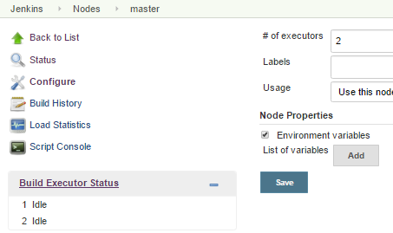

Set Environmental variables as follows

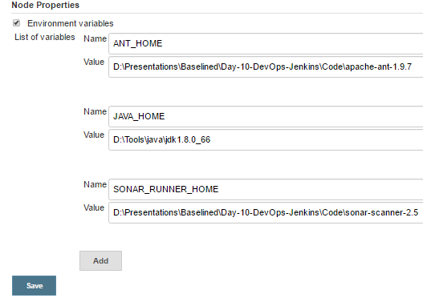

**Project Configuration**

1. **Checkout Source (GIT)**
2. **Plugins**

Jenkins -> Manage Jenkins -> Manage Plugins ->advanced

Install **Git Plugin** and dependency plugins to install software successfully

From this link <https://wiki.jenkins-ci.org/display/JENKINS/Git+Plugin>

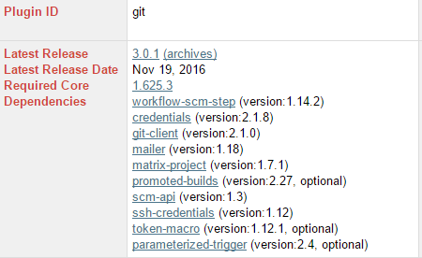

Note:-Make sure that all the dependencies plugins must be added

1. **Global Tool Configuration**

We can made the global configurations here

Jenkins -> Manage Jenkins ->Global Tool Configuration

1. **Git Installation**

Set Git path

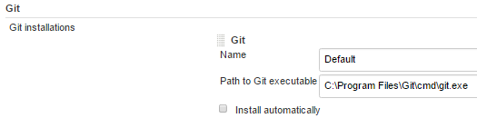

1. **JDK Installation**

Set Java_Home

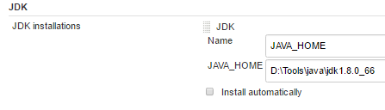

1. **Ant Installation**

Set Ant_home

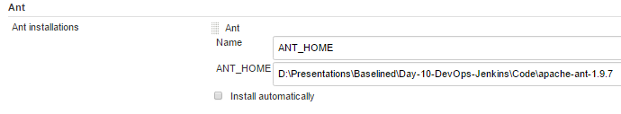

1. **Local Configuration**

Create New item->freestyle project

1. Under **Advanced Project Options**

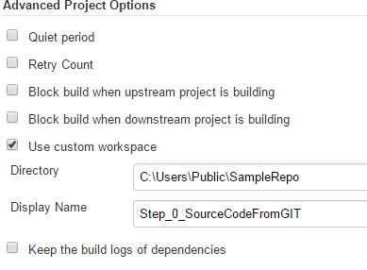

Directory : Mention the custom workspace directory

Display Name : Display name of the project

1. Under **Source Code Management** -> git

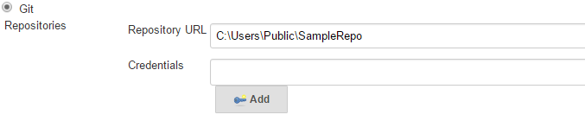

Repository URL: Cloned git repository URL

->Save->BuildNow

In Console

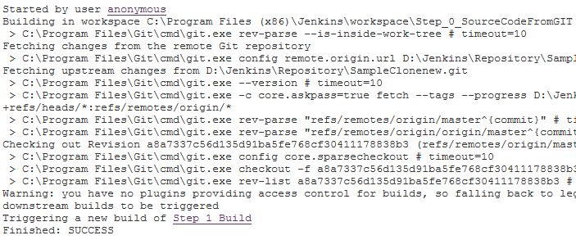

Can able to check out from the cloned repository

Build Successful!!!

1. In **Post build action->build other project**

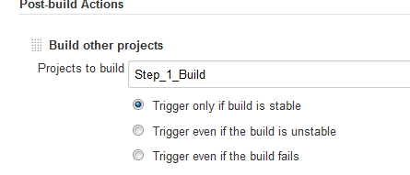

Give name of the other project which has to be run in sequential steps

1. **Compile the code**
2. **Plugins**

Jenkins -> Manage Jenkins -> Manage Plugins ->advanced

Install **Git Plugin** and dependency plugins to install software successfully

From this link <https://wiki.jenkins-ci.org/display/JENKINS/Ant+Plugin>

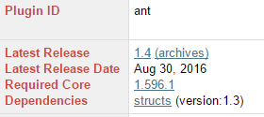

Note:-Make sure that all the dependencies plugins must be added

1. **Local Configuration**

Create New item->freestyle project

1. **Under Advanced Project Options**

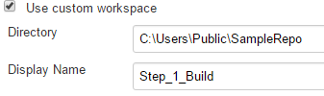

Directory : Mention the custom workspace directory

DisplayName :Display name of the project

1. Under **Source Code Management ->** git



Repository URL: Cloned git repository URL

1. **Build**

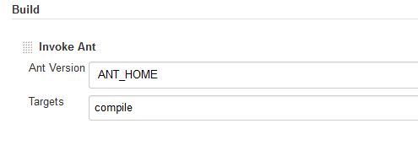

Select->invoke ant

Ant version : select the ant home in the dropdown

Targets : mention the target which has to be takes place(Target name as same as <target> specified in the build.xml)

->Save->BuildNow

In Console

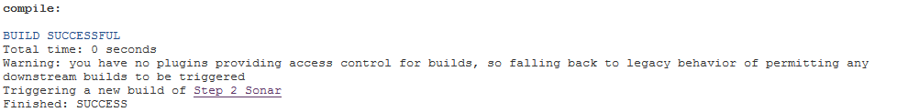

Build Successful!!!

4.In **Post build action**->build other project

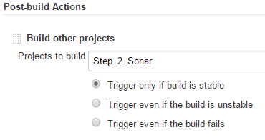

Give name of the other project which has to be run in sequential step

1. **Static code analysis-Sonar**
2. **Plugins**

Jenkins -> Manage Jenkins -> Manage Plugins ->advanced

Install **SonarQube Plugin** and dependency plugins to install software successfully

From this link <https://wiki.jenkins-ci.org/display/JENKINS/SonarQube+plugin>

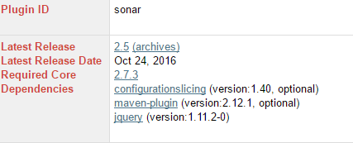

Note:-Make sure that all the dependencies plugins must be added

1. **Global Tool Configuration**

We can made the global configurations here

Jenkins -> Manage Jenkins ->Global Tool Configuration

1. **SonarQube Scanner**

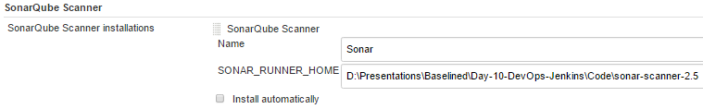

Name: name of our choice

Home: SonarScanner server home

Note:-server should be in running condition

1. **Configuration System**
2. **SonarQube Servers**

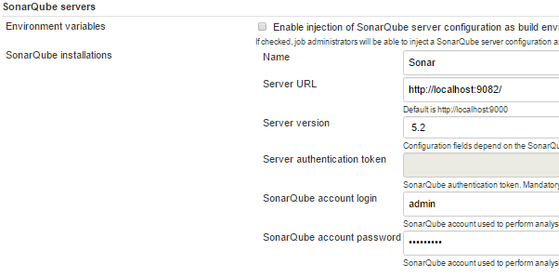

Server URL: URL in which SonarQube server is running

Note :-server should be in running condition

1. **Local Configuration**

Create New item->freestyle project

1. Under **Advanced Project Options**

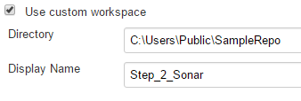

Directory : Mention the custom workspace directory

DisplayName :Display name of the project

1. Under **Source Code Management** -> git



Repository URL: Cloned git repository URL

1. **Build**

Select->Execute SonarQube Scanner

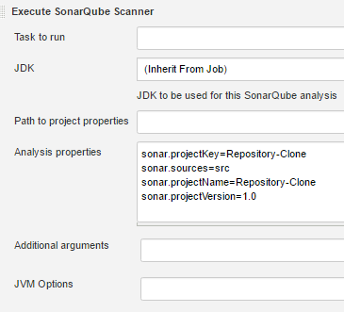

Have to mention the analysis properties (things mentioned in the sonar_runner.properties file)

->Save->BuildNow

Console

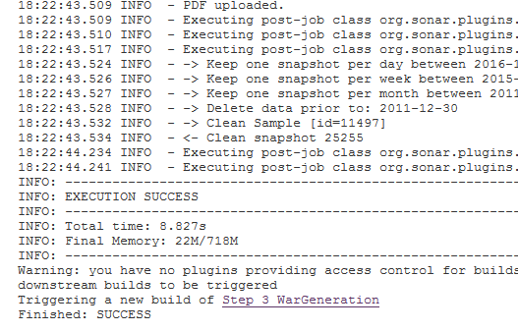

We can able to see the report by clicking sonarqube

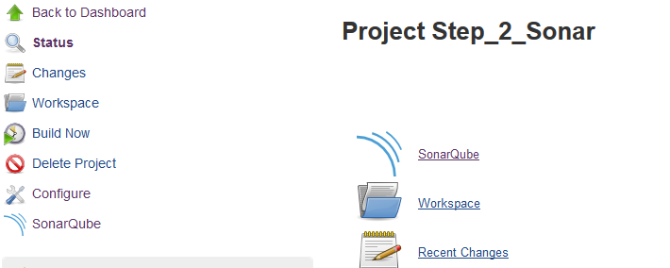

1. In **Post build action**->build other project

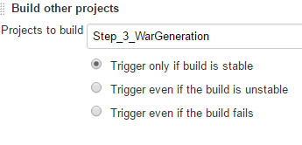

Give name of the other project which has to be run in sequential steps

1. **War Generation**
2. **Local Configuration**

Create New item->freestyle project

1. Under **Advanced Project Options**

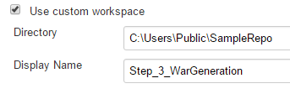

Directory : Mention the custom workspace directory

DisplayName : Display name of the project

1. Under Source **Code Management** -> git



Repository URL: Cloned git repository URL

1. **Build**

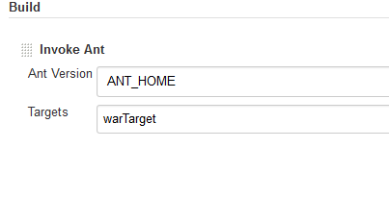

Select->invoke ant

Ant version : select the ant home in the dropdown

Targets : mention the target which has to be takes place(Target name as same as <target> specified in the build.xml)

->Save->BuildNow

In Console



1. In **Post build action**->build other project

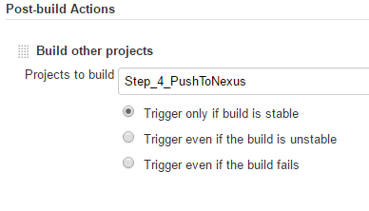

Give name of the other project which has to be run in sequential steps

1. **Push the war file into Nexus Repository**
2. **Plugins**

Jenkins -> Manage Jenkins -> Manage Plugins ->advanced

Install **Sonatype Nexus Plugin** and dependency plugins to install software successfully

From this link <http://download.sonatype.com/nexus/ci/latest.hpi>

Note:-Make sure that all the dependencies plugins must be added

1. **Configure System**

We can made the global configurations here

Jenkins -> Manage Jenkins ->Configure System

**Sonatype Nexus -** to connect with Nexus Repository

Select -> **Nexus Repository 2.x Server**

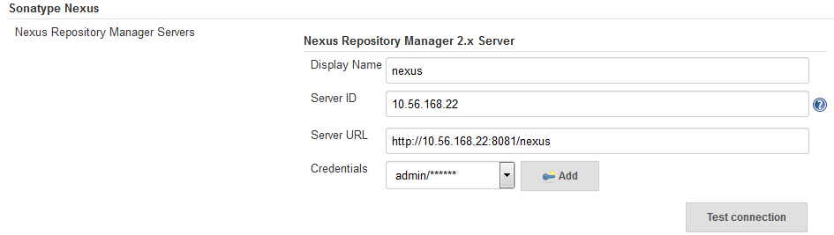

Under **Sonatype nexus**

1.Display Name : Name to display for nexus

2.ServerID : IP Address for nexus repository

3.Server URL: Url to connect with your nexus repository

4.Credentials:

We have to select **username with password** option in the dropdown and enter the credentials

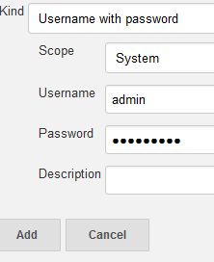

And click on add

If we click on **Test Connection** ->

If connection established it will show like

**Nexus Repository Manager 2.x connection succeeded (2 hosted release Maven 2 repositories)**

1. **Local Configuration**

Create New item->freestyle project

1. Under **Advanced Project Options**

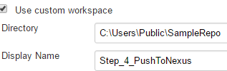

Directory : Mention the custom workspace directory

DisplayName :Display name of the project

1. Under **Source Code Management** -> git



Repository URL: Cloned git repository URL

1. **Nexus Repository Manager Publisher** - to publish artifacts into repository

**Add build step->** **Nexus Repository Manager Publisher**

1. Nexus Instance: select the instance name from dropdown which we have created in global configuration section

2. Nexus Repository: select the repository to which we have permission to access

3. **Package**: select the package

Under while fill the details about the artifact which we are going to upload into nexus repository

Group, artifact , version and packaging(ex.war)

Click on **Artifact-Add artifact path-Maven artifact**

And mention the file path where the war or jar file stored

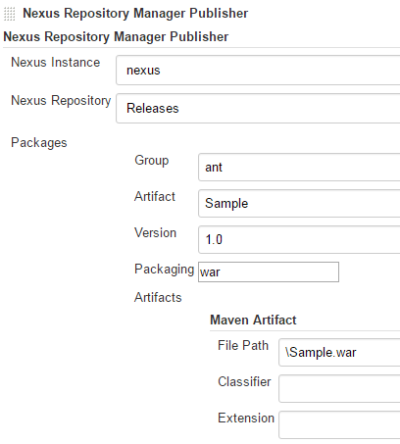

->Save->BuildNow

In Console

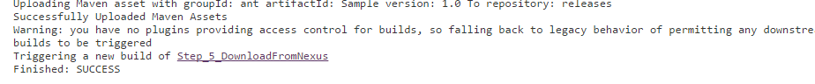

1. In **Post build action->**build other project

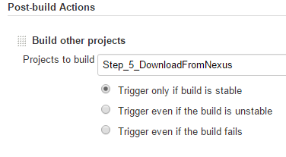

Give name of the other project which has to be run in sequential steps

1. **Download the war from Nexus Repository**
2. **Plugins**

Jenkins -> Manage Jenkins -> Manage Plugins ->advanced

Install **Repository Connector plugin** and dependency plugins to install software successfully

From this link <https://wiki.jenkins-ci.org/display/JENKINS/Repository+Connector+Plugin>

Note:-Make sure that all the dependencies plugins must be added

1. **Configure System**

We can made the global configurations here

Jenkins -> Manage Jenkins ->Configure System

**Artifact Resolver :**This Configuration has to be done once after the Artifacts stored into nexus then only we can retrieve .

**Artifact Resolver –** to retrieve artifact from Nexus

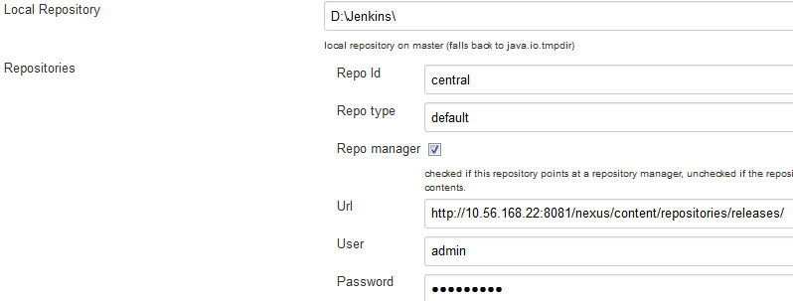

Under **Artifact Resolver**

1.Local Repository - we can able to give local directory path so that downloaded artifacts will be stored here

2.Repository

a)Repo Id –Central( by default)

b)Repo type- Default(by default)

c)Url-path where your files stores inside the repository

d)username and password - which is used when connecting the nexus repository

1. **Local Configuration**

Create New item->freestyle project

1. Under **Advanced Project Options**

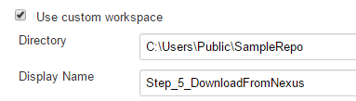

Directory : Mention the custom workspace directory

DisplayName :Display name of the project

1. Under **Source Code Management** -> git



Repository URL: Cloned git repository URL

1. **Artifact Resolver –** to retrieve (download) artifact from nexus

**Add build step -> Artifact Resolver**

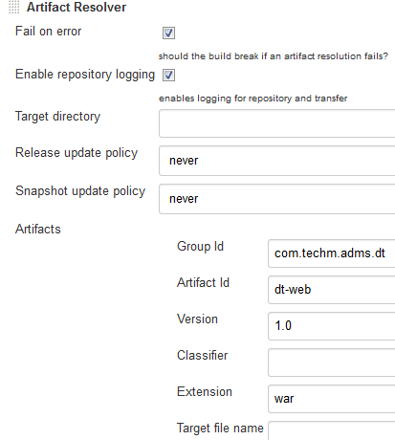

We have to mention the details about the artifact which we are going to download

1.Target directory-the space where the downloaded file will be copied

2.Release update policy and snapshot update policy we can select ad per our wish

3.Artifact-have to mention the artifact details which we are going to download from the nexus repository

->Save->BuildNow

**In Console**

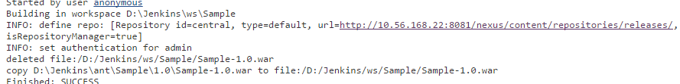

1. In **Post build action**->build other project

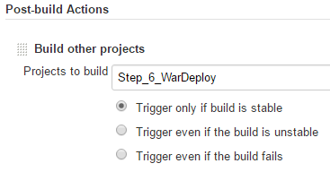

Give name of the other project which has to be run in sequential steps

1. **Deploy war into the server**
2. **Plugins**

Jenkins -> Manage Jenkins -> Manage Plugins ->advanced

Install **Deploy Plugin** and dependency plugins to install software successfully

From this link <https://wiki.jenkins-ci.org/display/JENKINS/Deploy+Plugin>

Note:-Make sure that all the dependencies plugins must be added

1. **Local Configuration**

Create New item->freestyle project

1. Under **Advanced Project Options**

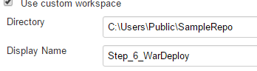

Directory : Mention the custom workspace directory

DisplayName :Display name of the project

2.Under source code management -> git



Repository URL: Cloned git repository URL

1. **Post-build action**

In **Post-build action->deploy war/ear to a container**

1.War/ear file- **\*.war(by default it will take the copied war from the workspace which we have mentioned)

2.Context path- The context path that the container should use to publish the WAR/EAR

3.Container-Add container->can able to select the server container which is used for deployment

a. manager username-username of the tomcat server

b. manager password-password of the tomcat server

c. tomcat url- URL in which tomcat is running

we can also mention n number of servers

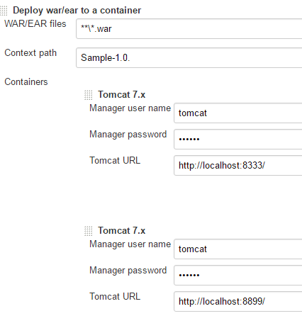

->Save->BuildNow

**In Console**

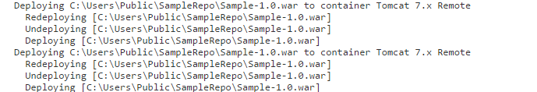

Project Steps completed Successfully!!!

**Jenkins Pipeline**

To create a build pipeline add **Pipeline Plugin**

From this link <https://wiki.jenkins-ci.org/display/JENKINS/Build+Pipeline+Plugin>

In Jenkins UI,Click on ”+” sign in order to add pipelin

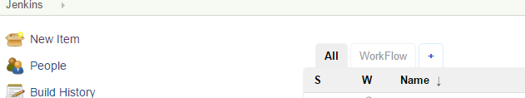

New pipeline

View name: name of the pipeline

click on build pipeline view

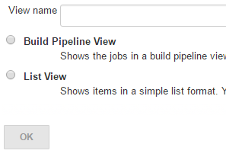

Click on OK

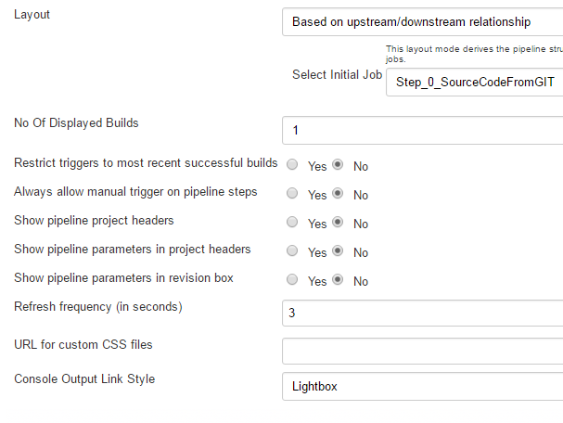

Select initial job: select the first project which has to be execute first in the pipeline

And click OK

Pipeline will appear ->click ->run

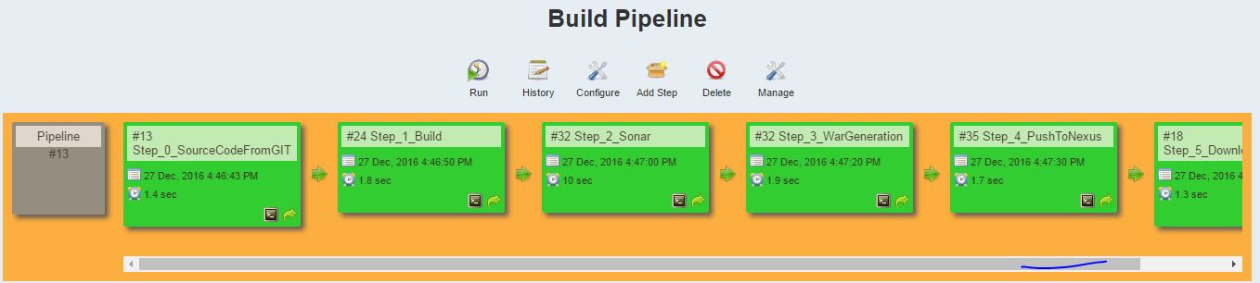

Pipeline executed successfully!!!